1/ Phishing
Why?
- 1) Sender address - 'manager@securemygataway.com' is not a legitimate Microsoft domain.
- 2) Lack of official branding - No Microsoft logo, footer, or official format.
- 3) No secure email footer or contact info - Legitimate support emails typically include proper
contact details and support links.

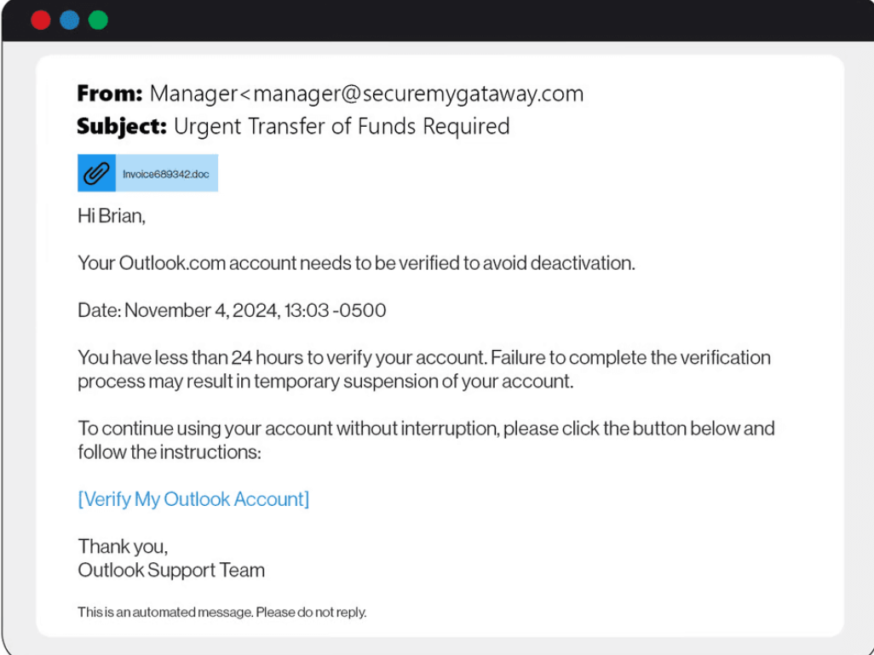
2/Phishing
Why?
- 1) Suspicious Email Address:
The sender address luke.json8000@gmail.com appears unprofessional and does not match the Arabic name “Rabee Kamal.”
- 2) Vague and Ambiguous Message:
The email does not explain what the document is or why it was shared.
It only uses a generic phrase like: “Please contact us if you need more information.”
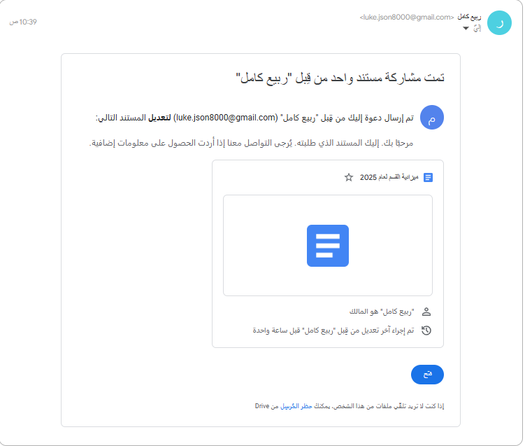
3/Phishing
Why?
1)Suspicious Phone Number:
The number provided, +1 (858)-555-7823, is likely fake or belongs to scammers.
PayPal never asks users to resolve disputes by calling external numbers.
2)Fear and Urgency Tactics:
The email claims a $600 invoice was issued without providing any order or product details.
It uses alarming language such as: Amount charged, must respond within 24 hours, and call this number.
3) Lack of Transaction Details:
No seller name, no product description, and no legitimate confirmation number are provided. This lack of transparency is typical of phishing emails designed to trigger panic-based clicks.

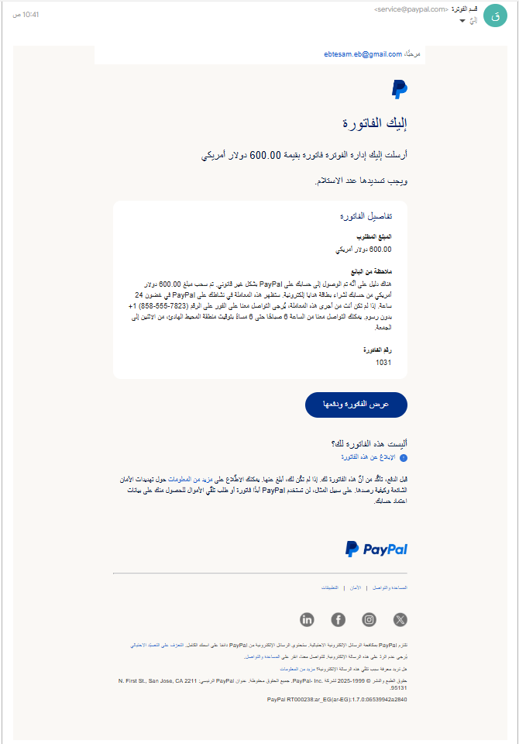
4/Phishing
Why?
- 1) Fake Email Address:
The sender address `noreplydhi@securemygateway.com` looks official, but the domain `securemygateway.com` is not related to DHL.
- 2) Impersonated Sender:
The message claims to be from DHL but uses the title “DHI Shipping Document “in red text. This is a common typo squatting trick, using “I” instead of “L” to mislead the recipient.
- 3) Missing Official Tracking Information:
There is no tracking number or detailed shipment info.
Real companies like DHL always provide a unique tracking ID.
- 4) Generic Message:
The message says "Your parcel sent by your customer..." without mentioning: - The recipient’s full name
- The sender’s name
- Any specific package details
This suggests the email was sent to many people at once (mass phishing).
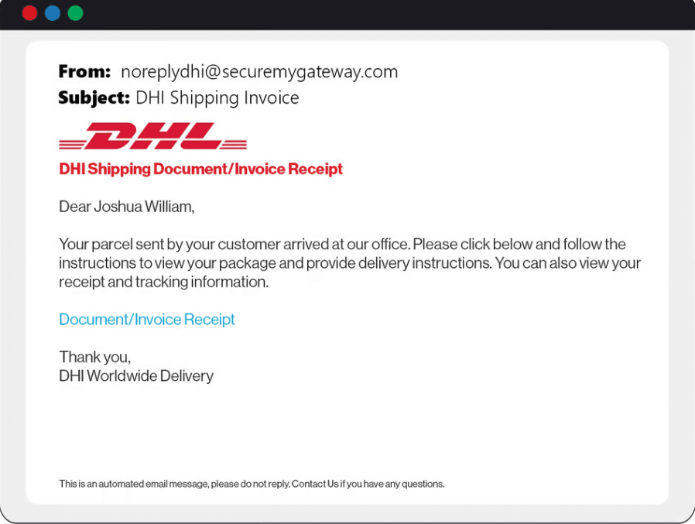
5/Phishing
Why?
- 1) Suspicious Sender Address:
The sender address pixel-giveaway@google.com looks official, but Google does not send calendar invites for giveaways or promotional campaigns.
- 2) False Promise of a Free Prize:
The message says:
“Congratulations, you’ve been selected to receive a free Pixel 7 Pro” This is a common phishing tactic used to lure people with fake rewards.
- 3) Enticing and Manipulative Language:
Phrases like “Custom invitation,” “To confirm,” and “Free” are used to create urgency and make the recipient click without thinking.
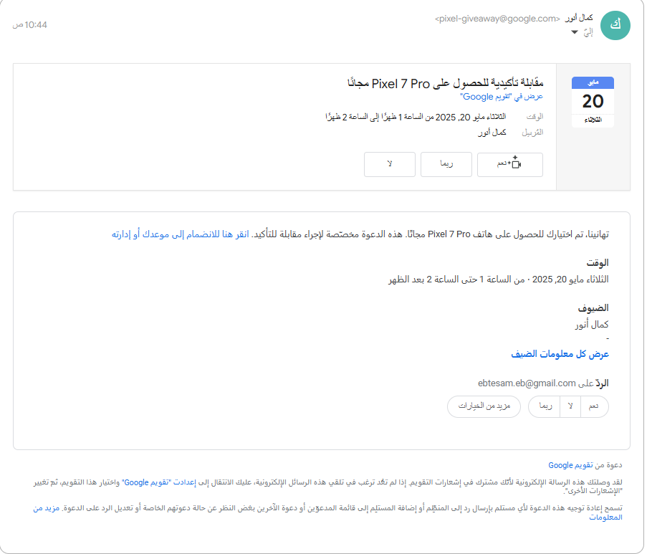
6/ Phishing
Why?
1) 1/Thesender'snumberisnotaSaudinumber
2) 2/SaudiPostsendsSMSmessagesforpayment,notWhatsApp.
3) 3/Thelinkmustbe(splonline).

